**3821ICT Work Integrated Learning Single Project – Lecture Notes**

**Week 2 – Lecture 1**

Tutor/ Assessor – Gary Scott [gary.scott@griffith.edu.au](mailto:gary.scott@griffith.edu.au)

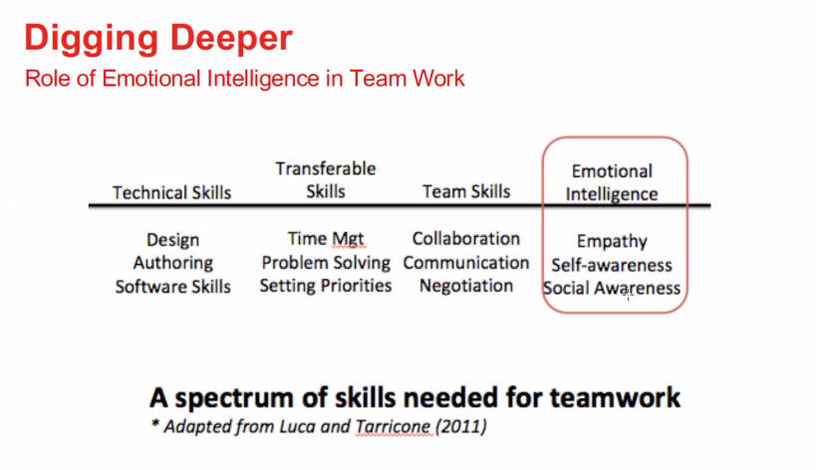

**Conduct of Project**

Teams

* Establish a team
* Setting context
* Setting goals
* Establish roles
  + Work out who is best suited to each role and requirement
* Develop procedures
* Decision making
* Team control management
  + Working effectively is a key outcome for the project
  + Build on the strengths of your team members

Project Meetings

Next Steps